Kevin Geraghty, Chairman  Michael Chizy, Vice Chairman  Ryan Fattman, Clerk  John L. Hebert  Michael Frustaci  James A. Smith, Town Administrator | 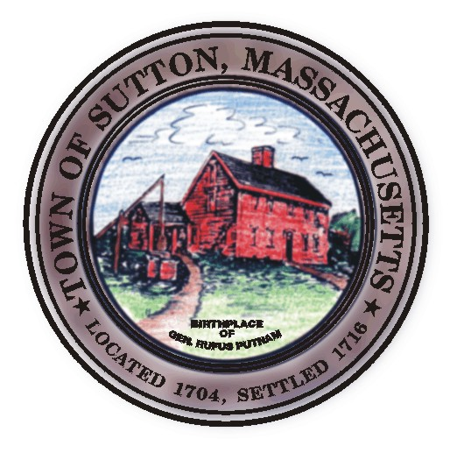 | Sutton Town Hall  4 Uxbridge Road  Sutton, Massachusetts 01590  (508) 865-8727  Fax: (508) 865-8721
Town Of Sutton
Board Of Selectmen

Meeting Agenda

7:00 p.m. – Tuesday, December 18, 2007

Sutton Town Hall, Selectmen’s Meeting Room

- Call to Order, Pledge of Allegiance at 7:00 p.m.

- Public Forum: Limited to 5 minutes per topic. Discussion or comments about town employees or agency members shall be avoided so as not to violate individual’s rights.

- Minutes
  - Board of Selectman minutes from 12/04/2007

- Sponsored Agenda and Action Items
- Appointment of Carol Levins to Board of Registrars
- Sale of Surplus Property
- 2008 License Renewals
- Holiday hours for all alcohol license holders

- Town Administrator’s Update

- Announcements
VII. Selectman’s Roundtable: Correspondence and Business Topics
VIII. Executive Session
IX. Adjournment

